**DAILY ONLINE ACTIVITIES SUMMARY**

|  |  |  |  |  |  |
| --- | --- | --- | --- | --- | --- |
| **Date:** | **27 June 2020** | | **Name:** | **KHATHEEJA SAFREENA.** | |
| **Sem & Sec** | **4th sem, 2nd year** | | **USN:** | **4al18cs037** | |
| **Online Test Summary** | | | | | |
| **Subject** | **---------** | | | | |
| **Max. Marks** | **----** | **Score** | | **---** | |
| **Certification Course Summary** | | | | | |
| **Course** | **INTRODUCTION TO R.** | | | | |
| **Certificate Provider** | **GreatLearning** | **Duration** | | | **6 hours** |
| **Coding Challenges** | | | | | |
| **Problem Statement:2 program** | | | | | |
| **Status: Executed** | | | | | |
| **Uploaded the report in Github** | | **Yes** | | | |
| **If yes Repository name** | | [http://shafreenasharief / lockdown-coding](http://shafreenasharief / lockdown-coding" \o "http://shafreenasharief / lockdown-coding)  [http://shafreenasharief / locked-down--certification-course](http://shafreenasharief / locked-down--certification-course" \o "http://shafreenasharief / locked-down--certification-course)  **[http://shafreenasharief / Daily\_Report](http://shafreenasharief / Daily_Report" \o "http://shafreenasharief / Daily_Report)** | | | |
| **Uploaded the report in slack** | | **Yes** | | | |

Certification Course Details: (Attach the snapshot and briefly write the report for the same)

Coding Challenges Details: (Attach the snapshot and briefly write the report for the same)

**CERTIFICATION COURSE SUMMARY:**

Today I started new course **INTRODUCTION TO INFORMATION R** through **GREAT LEARNING** the course is secluded for 6hrs. After the completion of course, certificate will be provided. I completed all the module .I attempted quiz ,which gave me a clear veiw about the topics that were thought and discussed.It consists of 7 modules which also include assessments**.**

**The concept covered in the course are as follows:**

* **INTRODUCTION TO R:**
* Basics of R.
* Importing and exporting Data. Types of data.
* Manipulations and plots
* **DESCRIPITVE STATISTICS:**
* Data collection.
* presentation and visuals.
* measures of central tendency. dispersion and correlation.

**THERE IS SNAP SHOT OF CERTIFICATE SECURED AFTER COMPLETION OF COURSE.**

#### 

#### ***CODING CHALLENGE :***

Today I solved 2 coding challenge,

**Write a C program to print kth digit**

**Given two numbers a and b, find kth digit from right of a^b.**

Input:

The first line of the input contains T denoting the number of test cases. Each of the next T lines contains three space separated positive integers denoting the value of a, b and k respectively.

Output:

For each test case, output the kth digit from right of a^b in new line.

Constraints:

1<=T<=100

1<=a, b <=15

1<=k<=|total digits in a^b|

**Example**:

Input:

2

3 3 1

5 2 2

Output:

7

2

**Hint**:

Output: 1

Explanation 3^3 = 27 for k = 1. First digit is 7 in 27

Output: 2

Explanation 5^2 = 25 for k = 2. First digit is 2 in 25

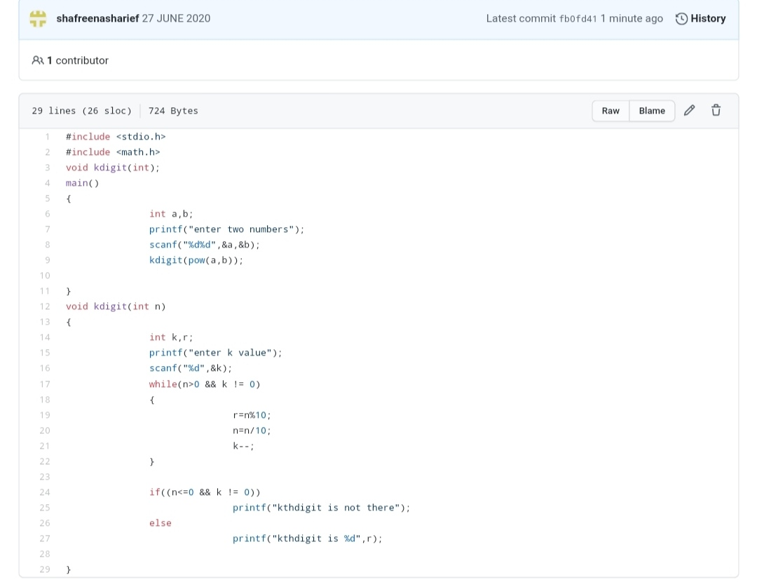

**2.Write a C++ program to declare a matrix of size 3\*3 matrix of size, initialize the**

**matrix and display them. Also find the sum of matrix elements, sum of main**

**diagonal elements and secondary diagonal elements.**

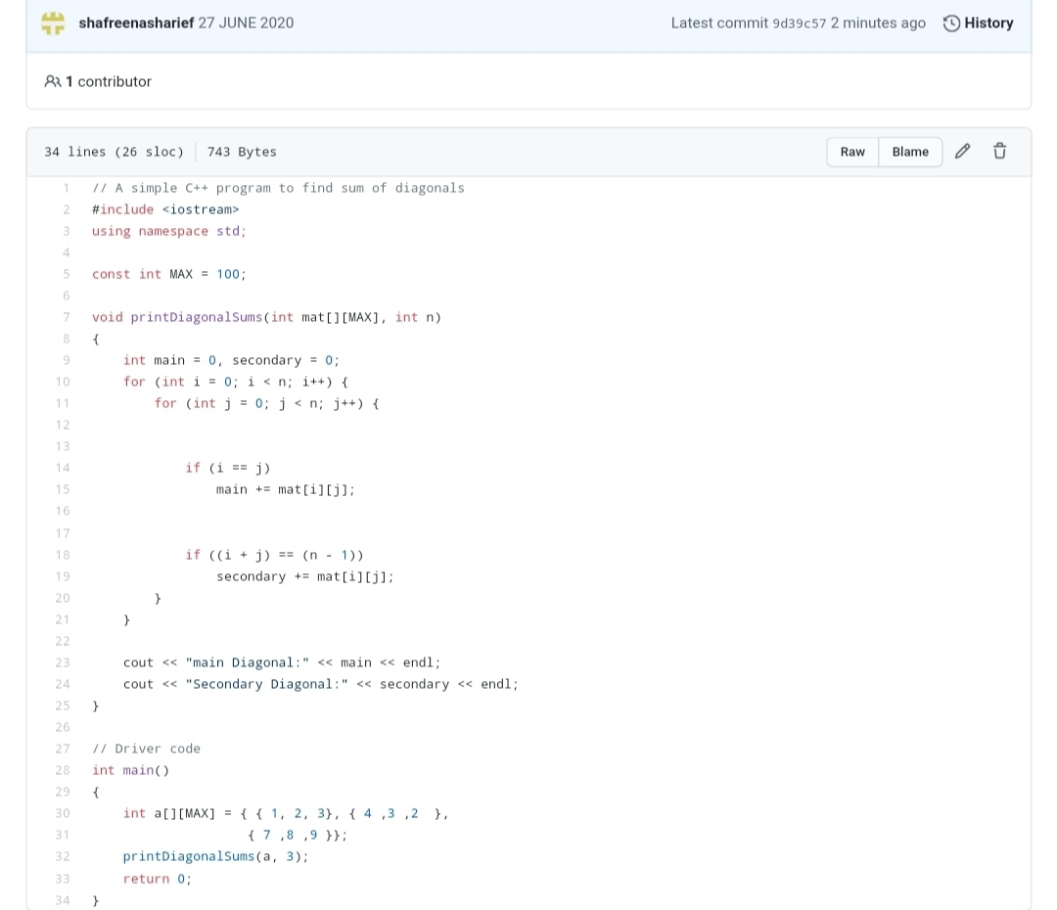

***EXTRA ACTIVITIES:***

Today I attended Online training on Loops and conditional statements C, from 2:30-4:00 pm at the last Quiz was conducted for 30 minutes.

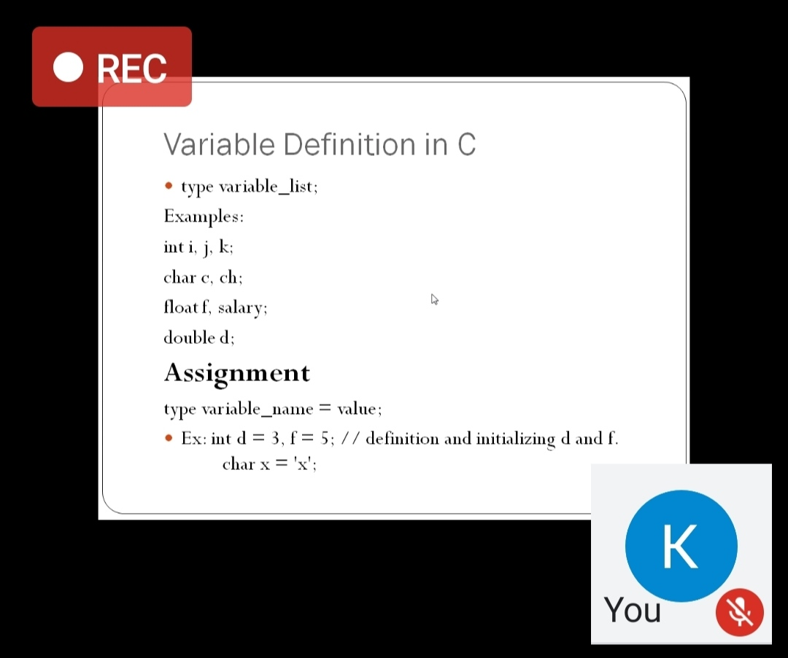

**SOLUTION** : I have uploaded the solution of the above 2 coding problems in my GitHub repository.

[http://shafreenasharief / lockdown-coding](http://shafreenasharief / lockdown-coding" \o "http://shafreenasharief / lockdown-coding)

[http://shafreenasharief / locked-down--certification-course](http://shafreenasharief / locked-down--certification-course" \o "http://shafreenasharief / locked-down--certification-course)

[http://shafreenasharief / Daily\_Report](http://shafreenasharief / Daily_Report" \o "http://shafreenasharief / Daily_Report)